# **Infosys 280 Assignment**

# **Student name: Audrey Zhang**

# **UPI: xzha590**

# Summary

**Finished and all should work fine:**

sign in, sign up

donate animal, adopt animal

management (navbar dropdown list): animal management, user management, analytical dashboard

default page (home page), about us page

user profile (navbar right dropdown)

sign out (navbar right dropdown)

recommend test account (Or you can pick one from database):

Admin: email: [admin@gmail.com](mailto:admin@gmail.com) pwd: admin

User: email: [test1@gmail.com](mailto:test1@gmail.com) pwd: test

|  |  |  |  |
| --- | --- | --- | --- |
| **A1** | **MARKS** | **COMMENT** | **FIXED** |
| D7 | 1/2.5 pts | EPC Model is missing. Please address this in your next submission.  T1: NOT FOR MONEY is not really a rule. This is a site-wide requirement. You won't have a field to enter any amount so it is implied  T2: Rules need to be something that you can collect and validate in the web app. Perhaps making sure Address of the user is Verified. | 1. T1 (YES) 2. T2 (YES) 3. EPC (YES) |

|  |  |  |  |
| --- | --- | --- | --- |
| **A2** | **MARKS** | **COMMENT** | **FIXED** |
| D7 | 0.3/0.5 pts | Use correct representations for the workflow. | YES |
| D9 | 2.5/3.0 pts | Good. | Implement the forms according to D8 (YES) |
| D12 | 2.2/3.5 pts | 1. Adopt page is not working. 2. Home page is default asp.net page which has no relevance with your application. 3. When user logs in, the sign in link should be visible false and  sign out link should be visible true. 4. Pick up date control should be a date control instead of normal text box control. | **1.** Adopt page (YES)  **2.** Default page(YES)  **3.** Sign out (YES)  **4.** Pick up date (YES) |

# D7.1(problem fixed):

|  |  |
| --- | --- |
| **Transaction 1** | Donate animals |
| **Routes** | The donor submits the animal details using “donation form”. The data is validated and submitted to the database. The donated animals are then allocated to the adopter in the management workflow. |
| **Rules** | * support animal’s information (type, name) * pick up location, pick up date |
| **Roles** | * Donator * Management system * Administrator |

|  |  |
| --- | --- |
| **Transaction 2** | Adopt animals |
| **Routes** | The adopter submits the personal details using “adoption form”. The data is validated and submitted to the database. If there is animal available, it will be allocated to the adopter in the management workflow. |
| **Rules** | * support personal information (name, email, phone number) * the type of animal |
| **Roles** | * Adopter * Management system * Admin |

# D7.2(**EPC Model Part,** missed IN A1 and A2):

**Animal Donation Workflow**

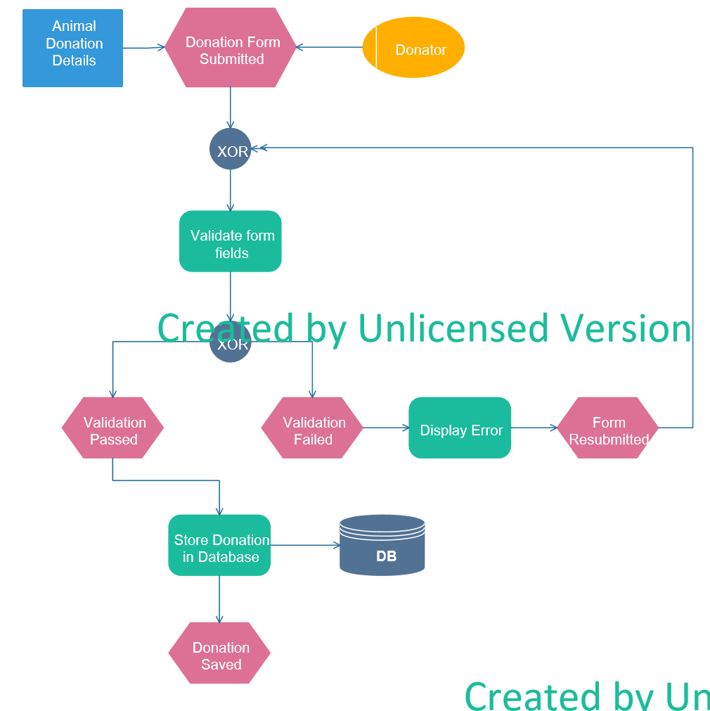

**Animal Adoption Workflow**

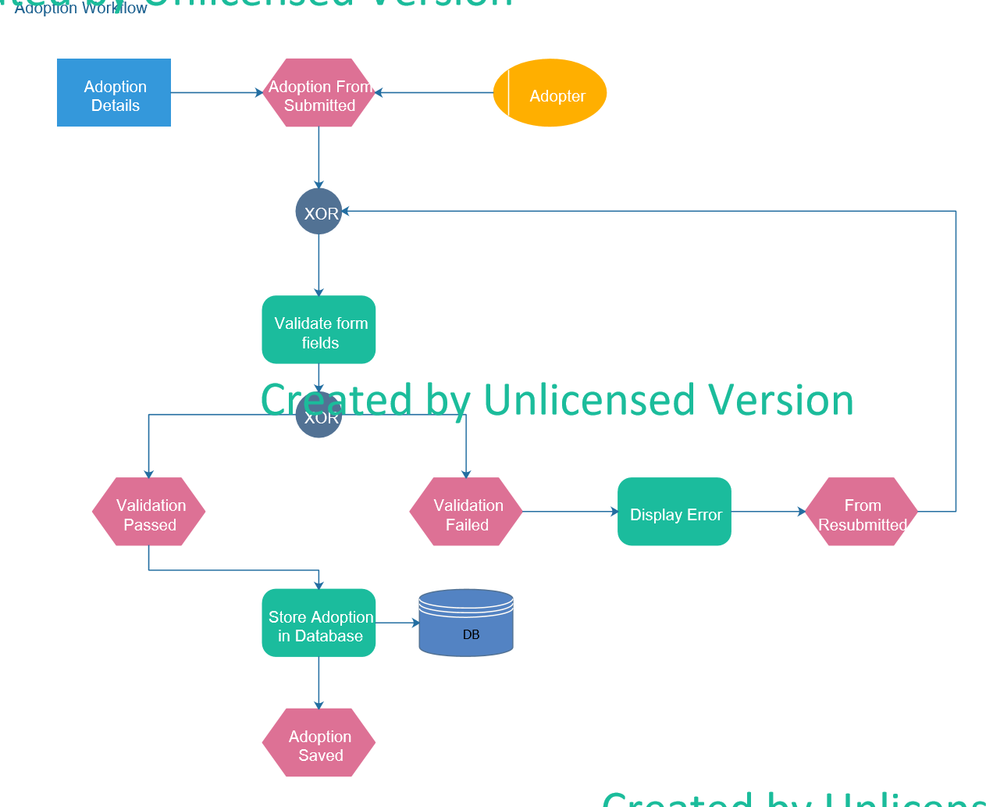

# D8:

Donation Form

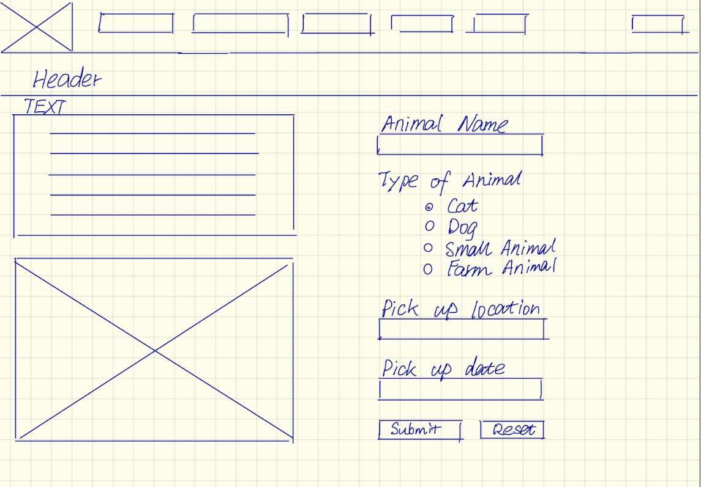

Adoption Form

# D9:

Codes in Zip and there are some screenshots

Donation Form

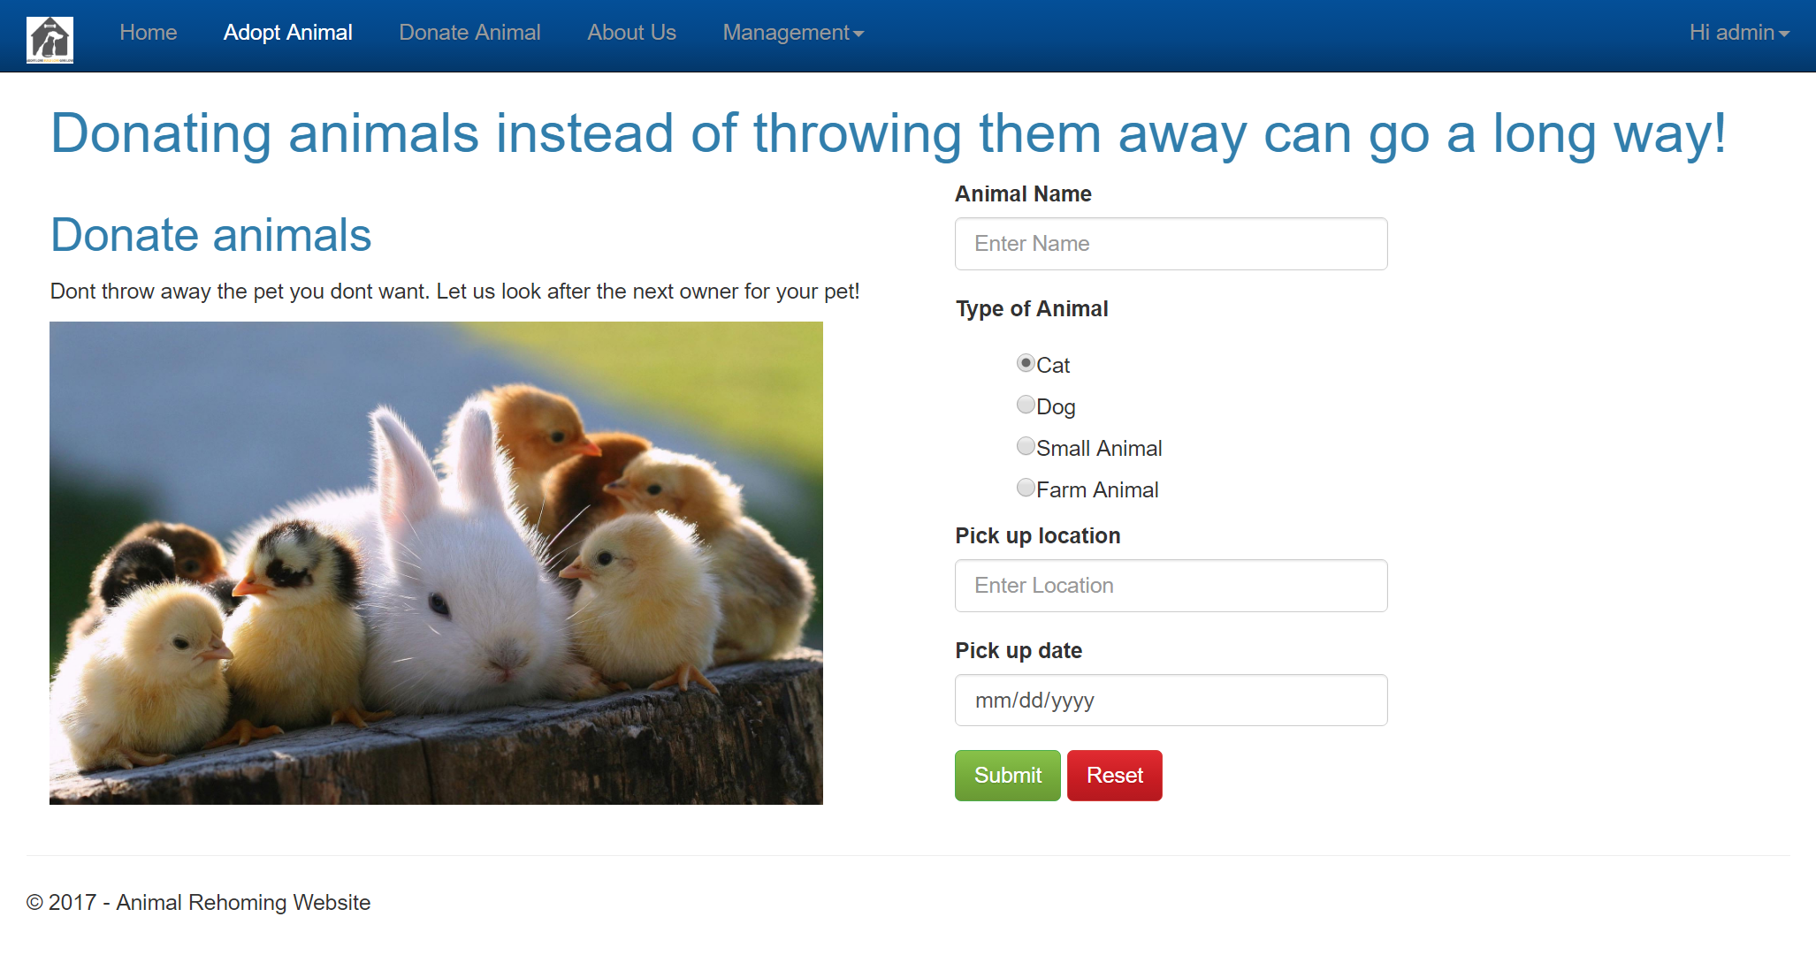

Adoption Form

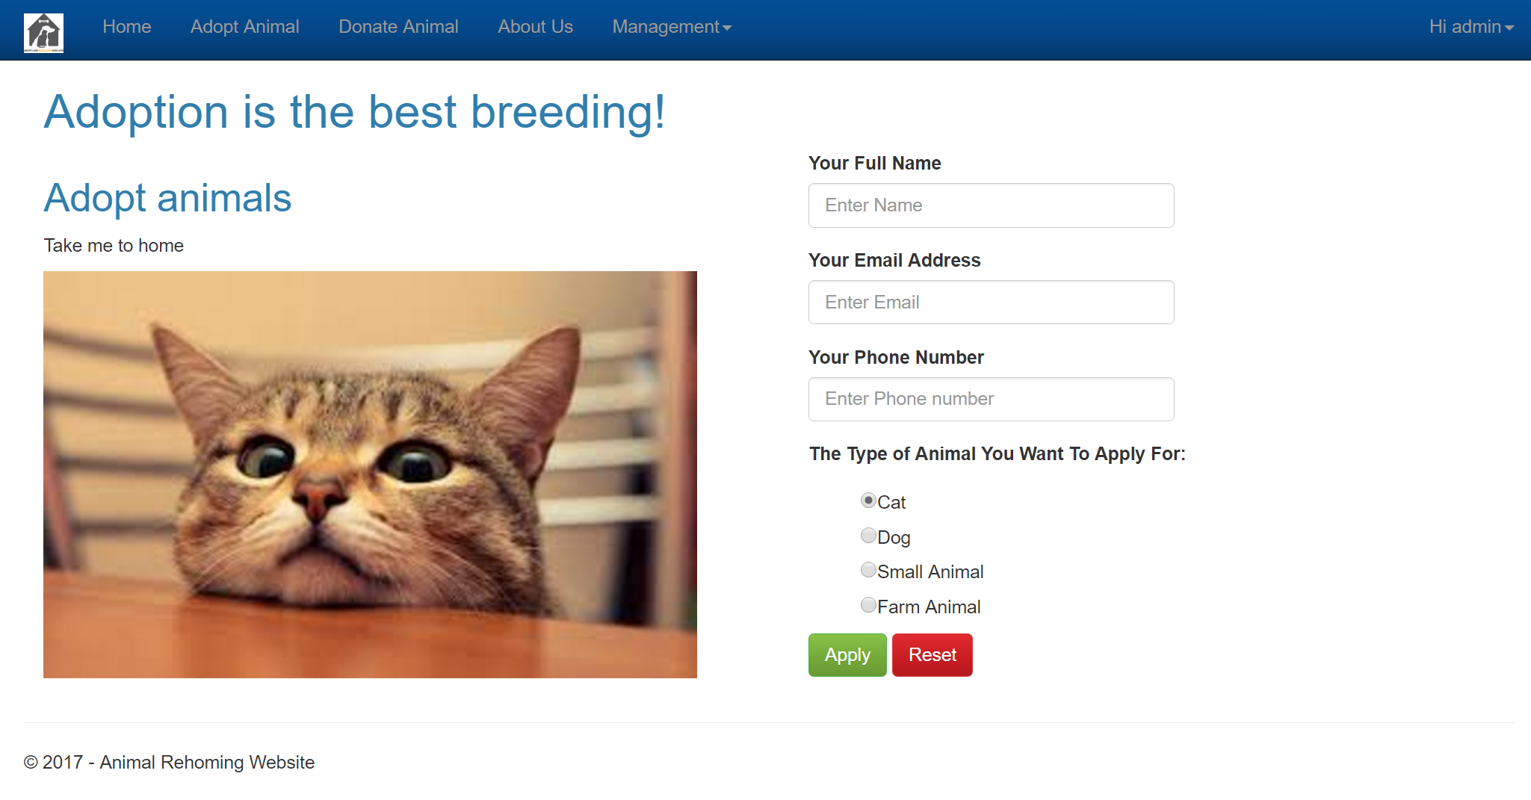

D10: Database Name: RehomingDB

Table Name: Donator

|  |  |  |  |  |  |  |
| --- | --- | --- | --- | --- | --- | --- |
| Column Name | Data Type | Length | Constraint | Allow Null | Default Value | Possible Values |
| DonatorId | int |  | PK | F |  | 1,2,3… |
| FullName | varchar | 50 |  | F |  | Audrey Z |
| Email | varchar | 50 |  | F |  | a@gmail.com |
| Password | varchar | 20 |  | F |  | 123abc |
| Active | int |  |  | F | ((0)) | 1/0 |
| CreatedDate | datetime |  |  | F | (sysdatetime()) |  |
| Role | varchar | 20 |  | F |  | User, Admin |

Table Name: Animal

|  |  |  |  |  |  |  |
| --- | --- | --- | --- | --- | --- | --- |
| Column Name | Data Type | Length | Constraint | Allow Null | Default Value | Possible Values |
| AnimalId | int |  | PK | F |  |  |
| Type | Varchar | 20 |  | F |  | Cat, dog… |
| RegNumber | Varchar | 10 |  | T |  | 0201704110000 |
| Active | int |  |  | F | ((0)) | 0/1 |
| Status | Varchar | 20 |  | F |  | Adopted/reserved/Available |
| CreatedDate | Datetime |  |  | F | (sysdatetime()) |  |
| Location | Varchar | MAX |  | F |  |  |
| DonatorId | int |  | FK | T(easy for test) |  | 1,2,3… |
| AnimalName | varchar | 20 |  | F |  | Brue.. |
| AdopterId | int |  | FK | T |  | 1,2,3… |
| AdopterName | varchar | 50 |  | T |  | Brian.. |
| PickUpDate | varchar | 50 |  | T |  | 2017/01/01 |

Table Name: Adopter

|  |  |  |  |  |  |  |
| --- | --- | --- | --- | --- | --- | --- |
| Column Name | Data Type | Length | Constraint | Allow Null | Default Value | Possible Values |
| AdoptorId | Int |  | PK | F |  | 1,2,… |
| FullName | varchar | 50 |  | F |  | Brian |
| Email | Varchar | 50 |  | F |  | b@gmail.com |
| PhoneNumber | Varchar | 20 |  | F |  | 123456 |
| CreatedDate | datetime |  |  | F | (sysdatetime()) |  |
| Active | int |  |  | F | ((0)) | 0,1 |
| AnimalType | varchar | 50 |  | F |  | Cat,dog,smallAnimal.. |

# D11:

Submit via Zip and there are some screenshots

Table Donator 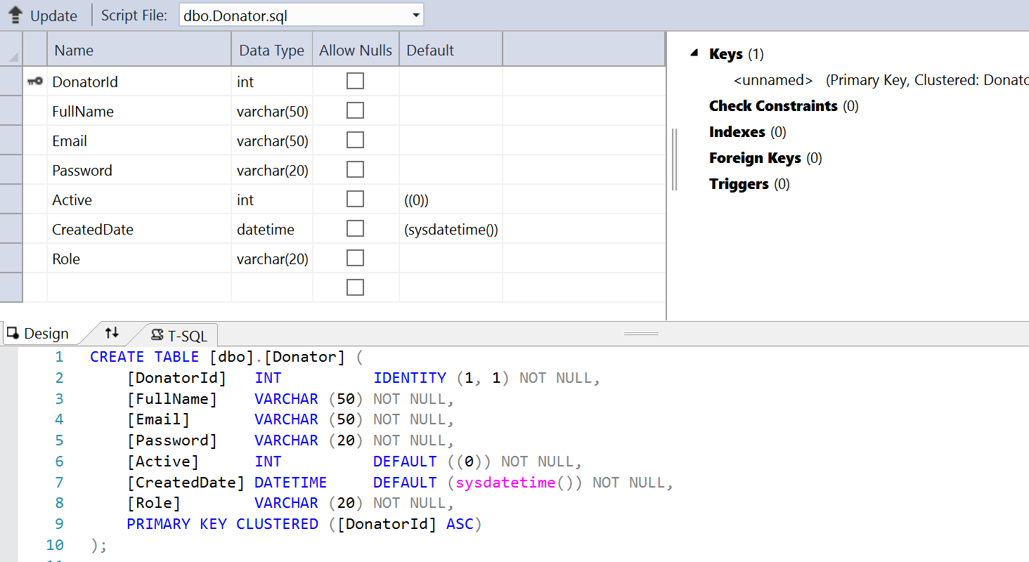

Table Animal

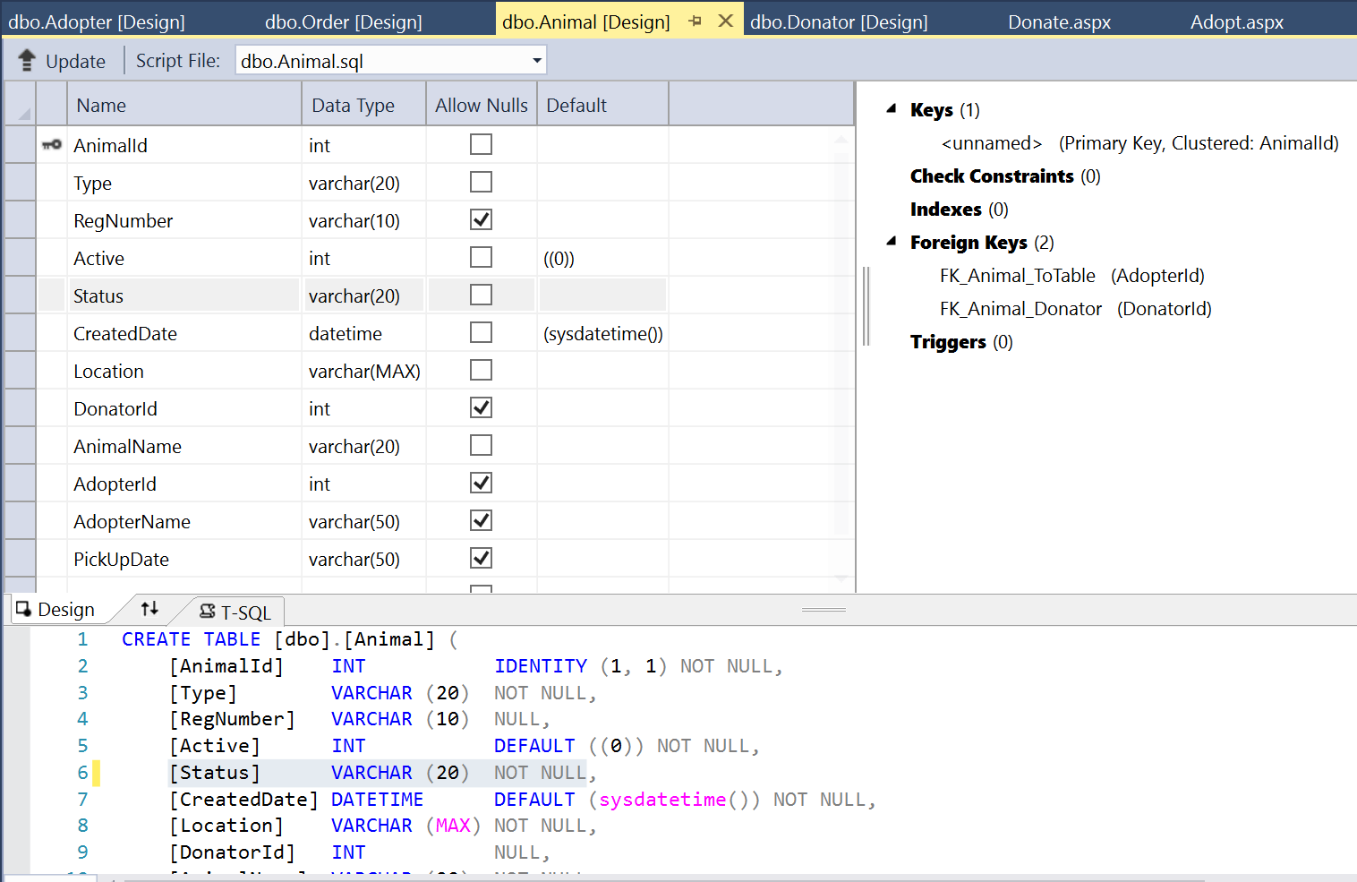

Table Adopter 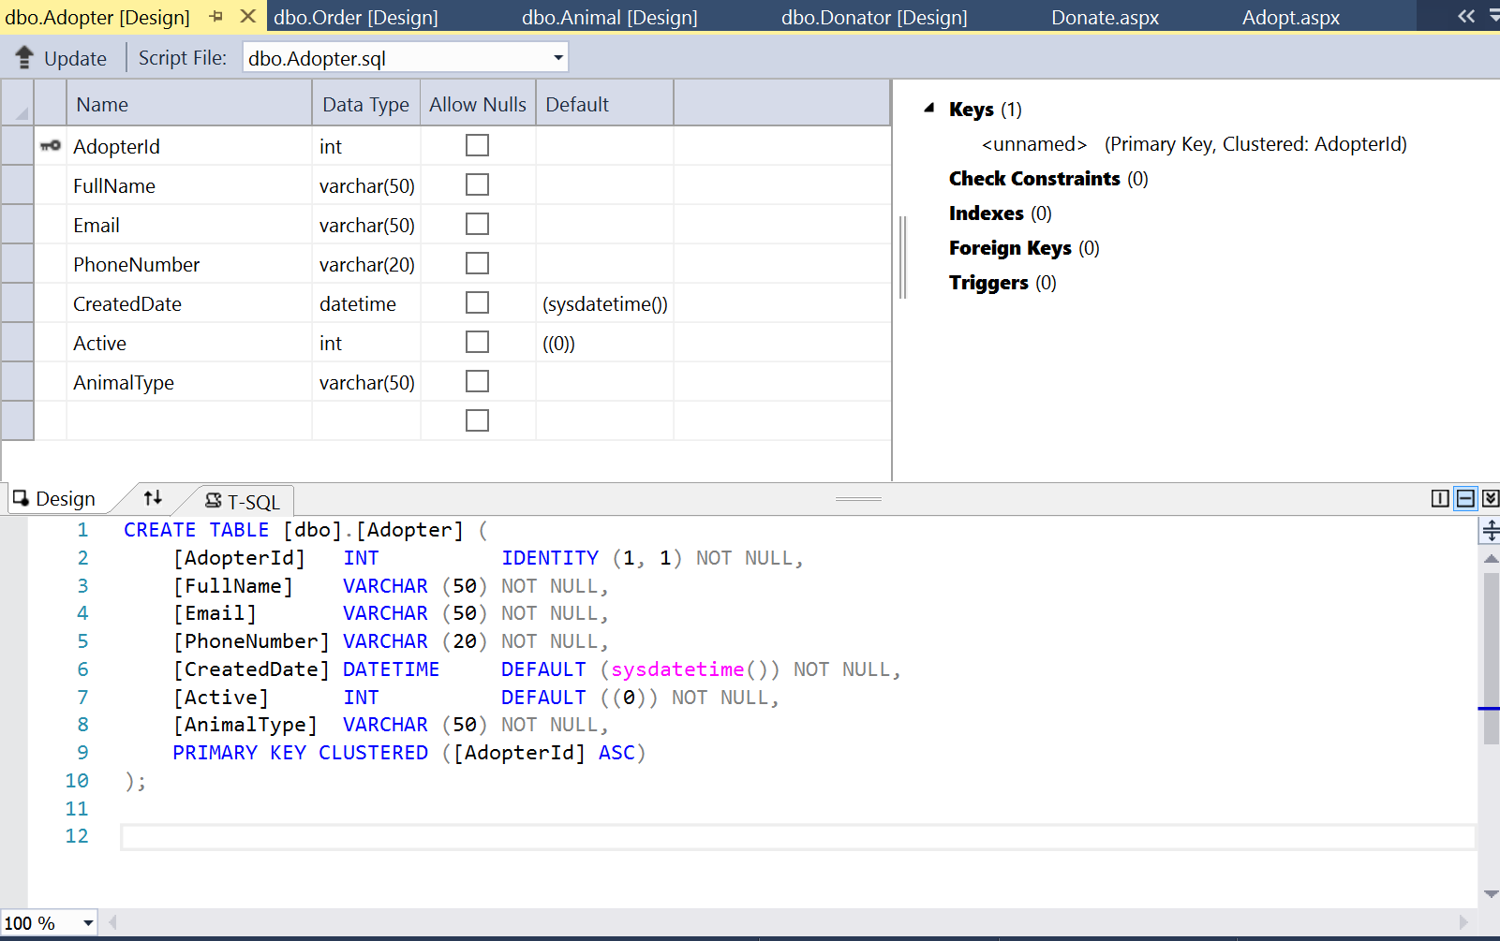

# D12:

Submit via Zip file

# D13:

Submit via Zip file

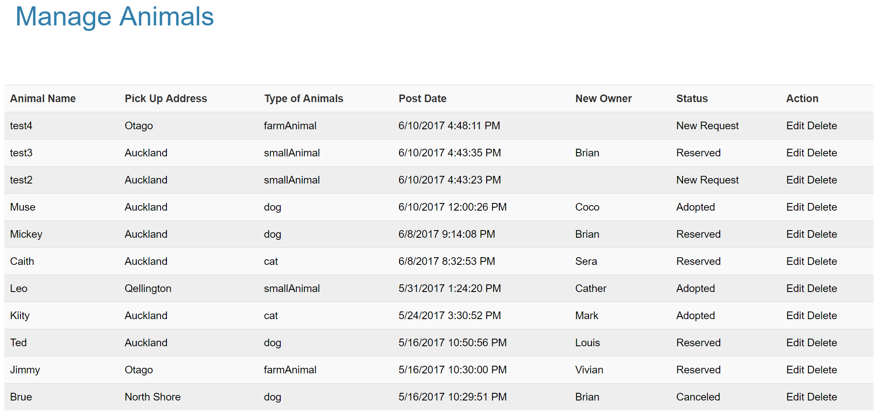

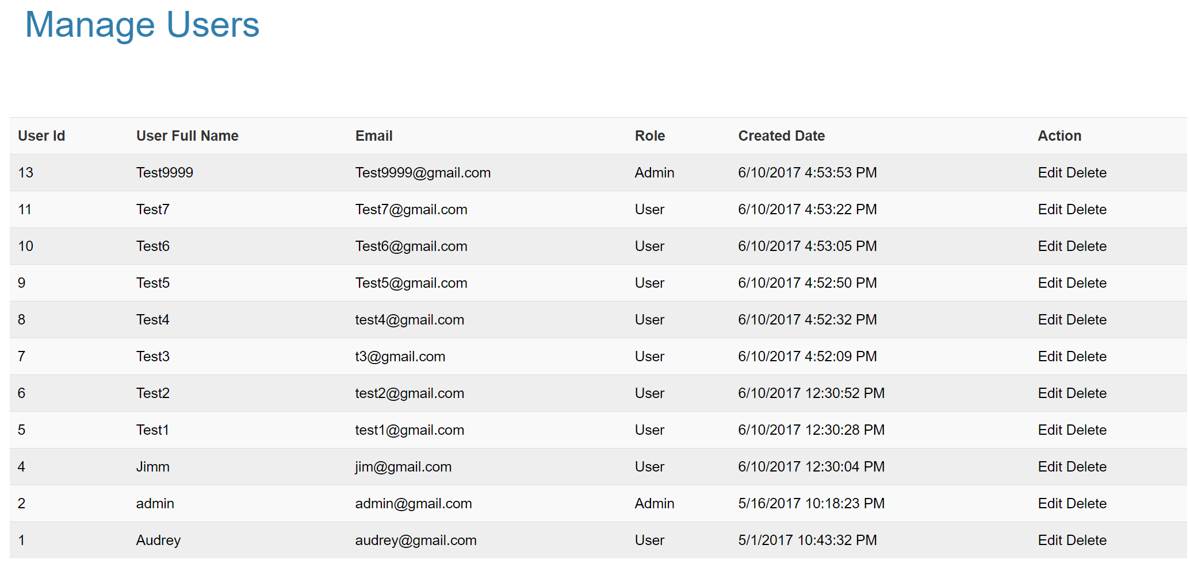

# D14:

Submit via Zip file

# D15:

Table Donator

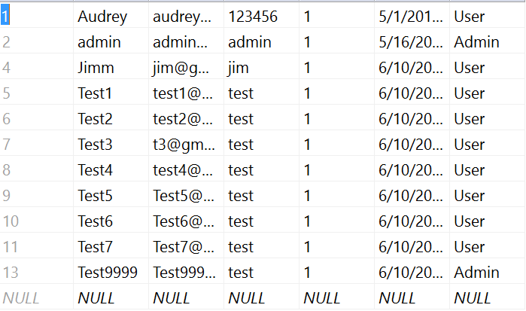

Table Animal

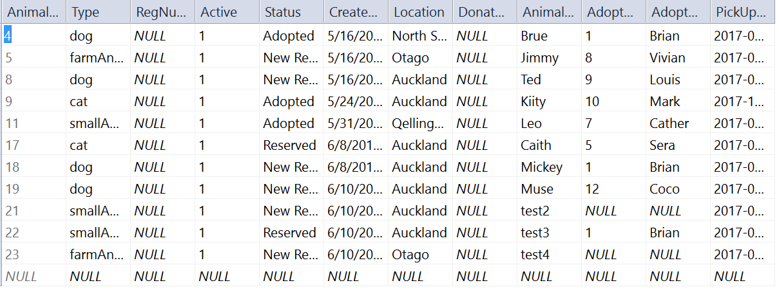

Table Adopter

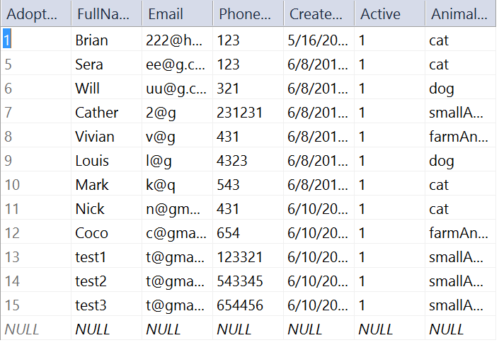

Table Order

# D16:

Submit via Zip file

